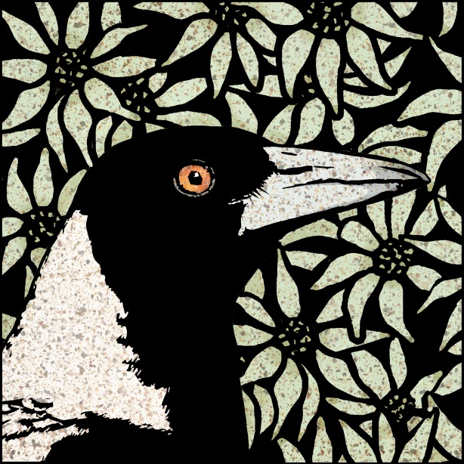
WATERLESS LITHOGRAPHY with ANNIE DAY
WARRINGAH PRINTMAKERS SUMMER SCHOOL
14, 15 & 16 January 2022
Waterless lithography is a safer printmaking technique allowing the artist to create a successful Lithographic image quickly using recycled commercial offset plates. During the workshop we take the mystery out of the technique while creating prints with colour. This course will provide both an introduction to Waterless Lithography and bring experienced students up to date with new developments in this interesting technique..
Course Fee: $330
Materials Fee: $25 Please bring materials fee on the first day.
Studio Membership: $30 (non-members only) Payable to Warringah Printmakers Studio online prior to or on the first day of the course.
Location: Warringah Printmakers Studio, corner Condamine & Lovett Streets MANLY VALE
Hours: 10 - 4
Bookings: Annie Day annieday@optusnet.com.au

Included in the Materials Fee: Plates, inks, Omnichrom pencil, notes & sundries.
Printmaking paper is for sale at the studio. Bring materials fee on the first day.

Registration form
Please complete this registration form & email to annieday@optusnet.com.au
Name
Address
Contact phone
Email address

To secure your place in the workshop, payment of $330 must be received by direct deposit.
Bank Transfer details:
Printmaking Sisters Pty Ltd
BSB: 012547
Account No: 369052441

If you have any questions at all, please email me, annieday@optusnet.com.au www.annieday.com.au

