WATERLESS LITHOGRAPHY with ANNIE DAY
WARRINGAH PRINTMAKERS SUMMER SCHOOL
8, 9 &10 January 2021
Waterless lithography allows the artist to create a successful Lithographic image quickly using aluminium plates. During the workshop we take the mystery out of the technique while creating prints with colour and texture. This course will provide both an introduction to Waterless Lithography and bring experienced students up to date with new developments in this interesting medium.
Course Fee: - $300
Materials Fee: - $25 Please bring materials fee on the first day.
Annual Studio Membership: - $30 (non-members only)
Location: Warringah Printmakers Studio, corner Condamine & Lovett Streets MANLY VALE
Bookings: Annie Day annieday@optusnet.com.au

Included in the Materials Fee: Plates, inks, Omnichrom pencil, notes & sundries.
Printmaking paper is for sale at the studio. Please bring materials fee on the first day.

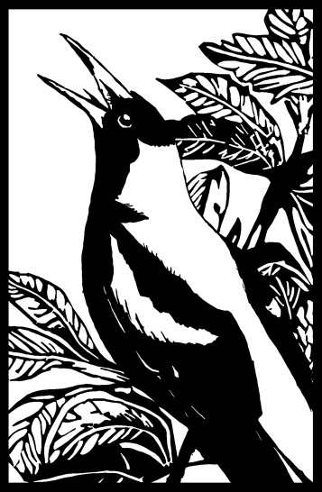

Registration form
Please complete this registration form & email to annieday@optusnet.com.au
Name
Address
Contact phone
Email address

To secure your place in the workshop, payment must be received by direct deposit
Bank Transfer details:
Printmaking Sisters Pty Ltd
BSB: 01254
Account No: 369052441

If you have any questions at all, please email me, annieday@optusnet.com.au www.annieday.com.au

